Solution Architecture

Date | 03 July 2026
Team ID | SWTID-2026-9778
Project Name | Credit Card Approval Prediction
Maximum Marks | 5 Marks

Solution Architecture Diagram:

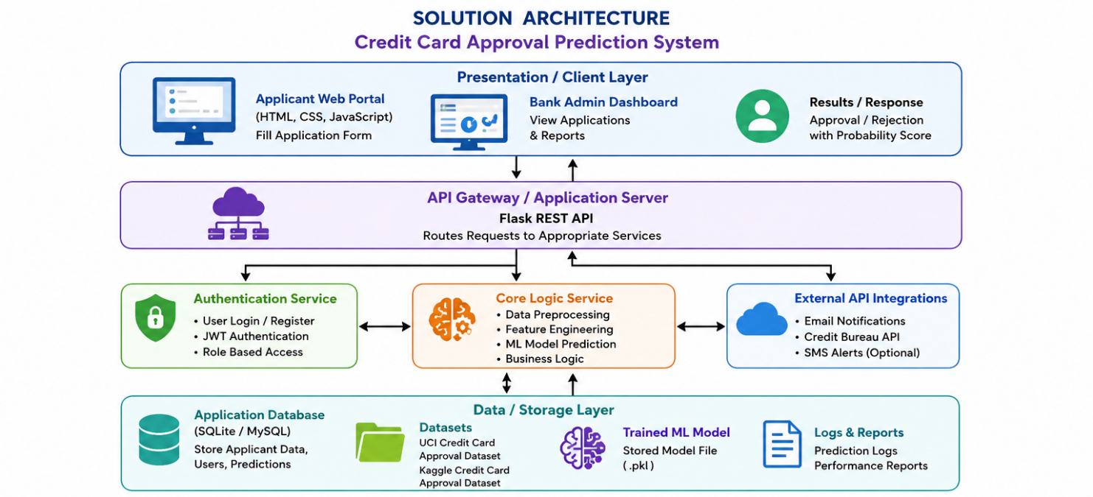

Component Description Table

Component Name | Description / Role in Architecture | Technologies Used
Presentation Layer | Collects applicant details and displays prediction results. | HTML,CSS,Javascript
API-Gateway | Receives requests and connects user interface with backend services. | Flask REST API
Core Logic Service | Processes data and predicts credit card approval using machine learning. | Python, Scikit-learn, Pandas, NumPy
External API Integrations | Sends notifications and optionally retrieves credit information. | SMTP Email API, Credit Bureau API
Authentication Service | Verifies user identity and manages secure access. | Flask Login, JWT
Data Layer | Stores applicant data, datasets, trained models, and prediction results. | SQLite/MySQL, CSV, Pickle (.pkl)

